**FOOD PRODUCTION AND CONSUMPTION IN AFRICA**

*How can we do better?*

The food situation in Africa has long since been dismal. Hunger and famine in the continent date back as far as the 1960s. Although blessed with many natural resources, both edible and non-edible, the continent struggles to feed its inhabitants.

An analysis was carried out on food production and consumption in 45 African countries to pinpoint the problem in food supply and offer solutions to- not just Africa's food shortage problem- but the world at large.

The data dates from 2004 to 2013. From the analysis, 45 countries produced large quantities of food, yet the number of calories made available to each person in a day was low.

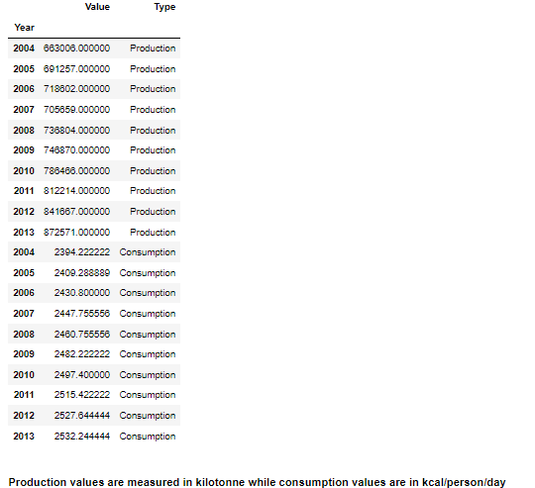

According to the National Health Service (NHS), UK, the recommended daily intake of calories is 2000 kcal for women and 2500 kcal for men. Note that this figure largely depends on age, lifestyle, and size. Thus, in a continent as labor-intensive as Africa, I believe that calories per capita should be above average.

With a large amount of food production, consumption should be high and far from the average. However, this is not the case. Many reasons for this phenomenon come to mind. I will outline just a few.

1. Overpopulation: Africa is the second most populous continent in the world. If all the food produced were evenly distributed (which is not the case), the amount of food getting to each person would be relatively small. However, this is no excuse because China- one of the countries in the most populous continent, Asia- had 3108 kcal/person/day in 2013.

2. Economic situation: The agricultural economy employs 65-70% of Africa’s labor force and typically accounts for 30-40% of GDP (Gross Domestic Product). More than 70% of the continent poor live in rural areas, and agriculture is their most important economic activity. Agriculture is the backbone of most African economies, so much of what they produce is sold to foreign countries. This leaves little available to the local markets.

Can you think of more reasons?

In 2004, three African countries showed higher than average calorie per capita.

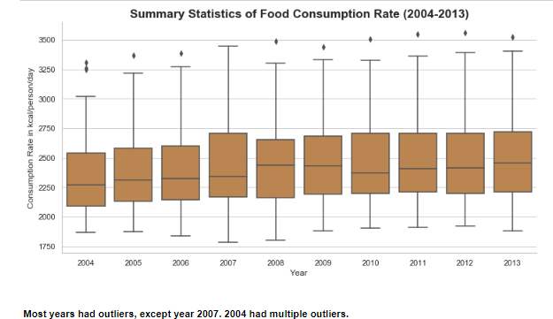

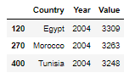

Egypt, Morocco, and Tunisia had high calories per capita, not just in 2004 but in other years.

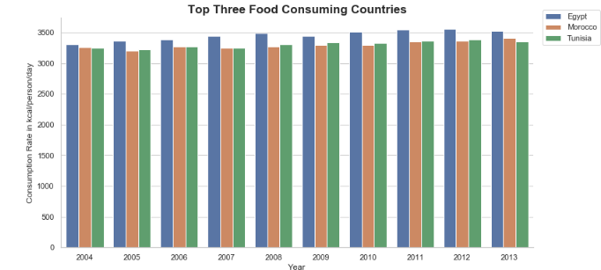

They consistently had above 3000 kcal/person/day throughout the ten years.

While this is true and commendable, some countries had less than 2000 kcal/person/day, as seen in the box plot below (the lower whisker shows the minimum value).



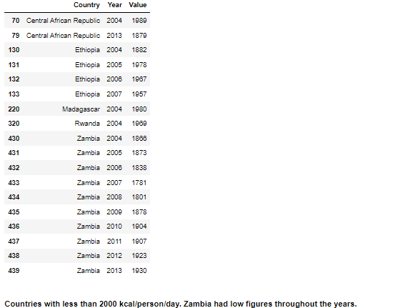

This fact should serve as a call to attention for Non-governmental organizations(NGOs), government officials, and the world at large.

Thankfully, there is no problem without a solution, and I would offer a few.

1.) Increase in Production: One of the ways to increase food consumption/supply is to increase production. In my analysis, I saw that three countries were notable food producers, producing large quantities while others were far behind in production.

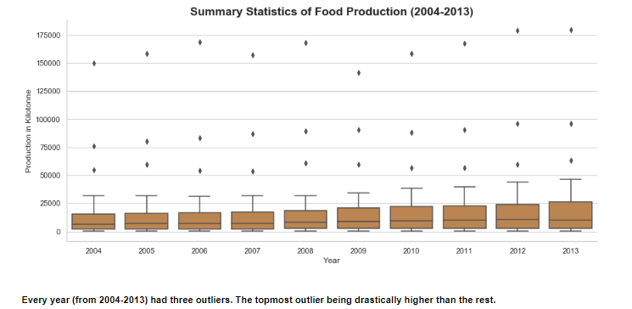

The upper whiskers in all the boxes were below 50,000 kilo-tonne, which is low compared to the outlier points. The topmost outlier is significantly higher than the rest. The top three food-producing countries were Nigeria, Egypt, and South Africa.

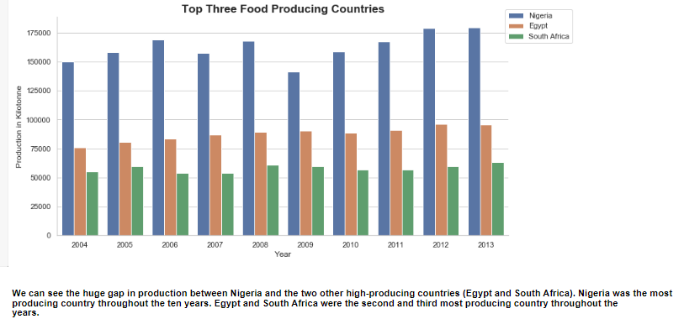

Note that Egypt- the second most producing country- had the highest calorie per capita (above 3000 kcal/person/capita) throughout the ten years. Hence, I believe increasing production can increase food supply.

Also, there seems to be a strong positive correlation between food production and consumption.

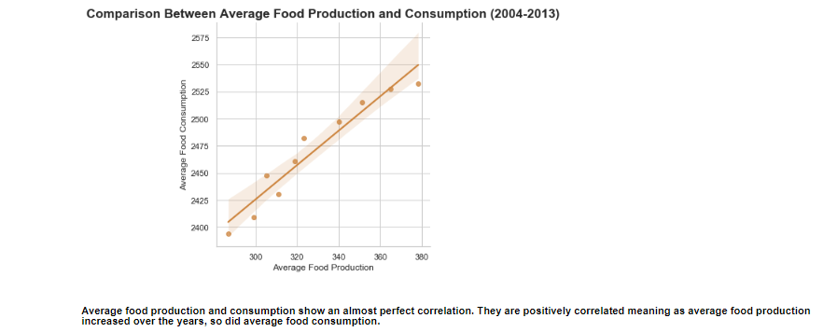

As food production increases, food consumption increases.

2.) Multiple Income: Another way to combat the food shortage worldwide is to diversify the economy. Relying so much on agricultural produce to sustain the economy is possibly why though Nigeria is the most producing country, it has a low calorie per capita. The local markets should be saturated with food before selling to foreign markets. It is well known that multiple income sources are better than one. Though Egypt relies on agriculture to fund the country, it also relies on media, petroleum imports, natural gas, and tourism. Egypt is well known for its tourist attractions, having one of the seven wonders of the world within its borders. Whereas, in Nigeria, agriculture remains a strong pillar of the country’s economy. The other pillars are oil/gas, mining, and forestry. In previous years, oil/gas value has been decreasing.

3.) Reduce Food Waste: Another possible reason for high production and low consumption is the wastage of food. Food is wasted mainly because of inefficient preparations, and inadequate storage facilities. Food supply can be increased by building more storage facilities and constructing more efficient methods of processing food for storage or transport.

4.) Feed the Nation: Based on the analysis, I recommend that food be grown to feed the community first before selling out of the country. Farmers should produce cash crops when there are enough food crops in the market. There should also be programs that allow farmers to know when there is sufficient food for everyone.

5.) Improve existing infrastructure: Bad roads, storage facilities, and food processing equipment can lead to food spoilage before it can get to the consumers. Improving these infrastructures will help reduce food spoilage and increase supply.

The overall trend in food production and consumption increased from 2004-2013.

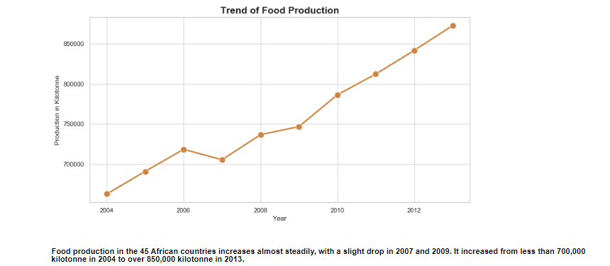

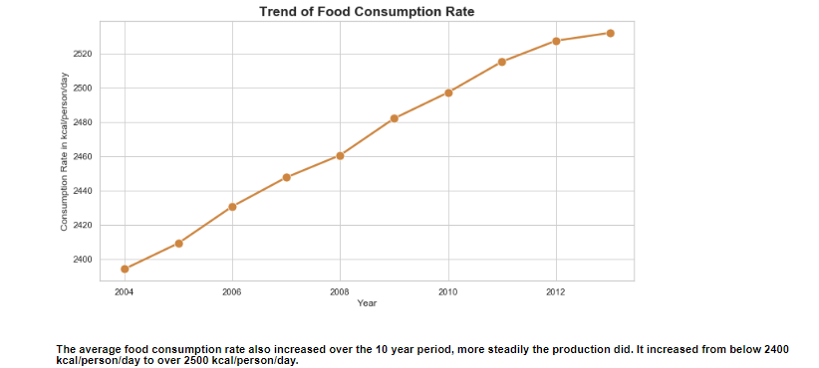

While this is commendable, we must still make active efforts to further increase food consumption. With these points, I believe I have stirred your mind to think of ways to better lives.

Food production in African countries (2013).

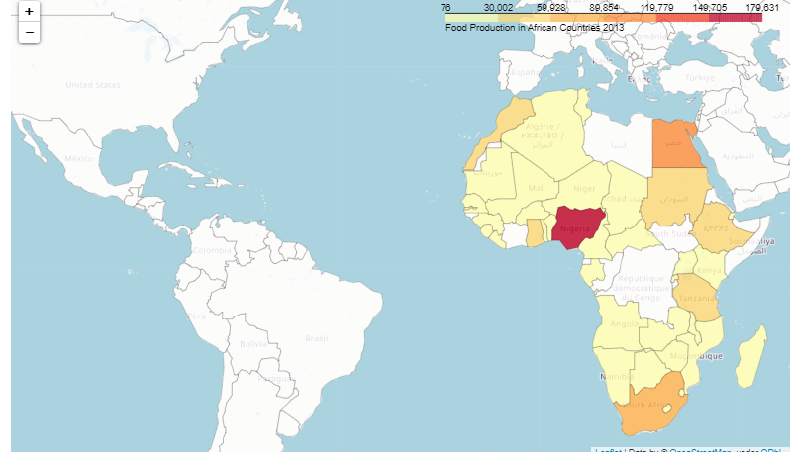

**REFERENCES**

1.) https://www.nhs.uk/common-health-questions/food-and-diet/what-should-my-daily-intake-of-calories-be/#:~:text=An%20ideal%20daily%20intake%20of,women%20and%202%2C500%20for%20men.

2.) https://www.statista.com/statistics/1094250/daily-per-capita-calories-supply/

3.) https://www.conserve-energy-future.com/causes-effects-solutions-food-insecurity.php